SCRIPTS:

CODE FOR ENEMY  
using UnityEngine;

using UnityEngine.SceneManagement;

public class enemy : MonoBehaviour

{

public float speed = 5f;

private Vector3 moveDirection;

private void Start()

{ moveDirection = transform.right; }

void Update()

{

Move();

}

void Move()

{ transform.Translate(moveDirection \* speed \* Time.deltaTime);

}

// Collision detection

private void OnCollisionEnter(Collision collision)

{ if (collision.gameObject.CompareTag("Player"))

{ SceneManager.LoadScene(1);

}

if (collision.gameObject.name == "end")

{

// Rotate 180 degrees to reverse direction

transform.Rotate(0, 90, 0);

moveDirection = transform.right;

}

}

}

PLAYER CODE:

using UnityEngine;

using UnityEngine.SceneManagement;

public class samecollide : MonoBehaviour

{

public static int score = 0;

private void OnCollisionEnter(Collision collision)

{

if (collision.gameObject.name == "Capsule")

{

SceneManager.LoadScene(2);

}

}

}

Move:

using System.Collections;

using System.Collections.Generic;

using UnityEngine;

public class mv : MonoBehaviour

{

public float moveSpeed = 5f;

public float rotationAmount = 90f;

void Update()

{

if (Input.GetKey(KeyCode.UpArrow))

{

transform.Translate(Vector3.forward \* moveSpeed \* Time.deltaTime);

}

if (Input.GetKey(KeyCode.DownArrow))

{

transform.Translate(-Vector3.forward \* moveSpeed \* Time.deltaTime);

}

if (Input.GetKeyDown(KeyCode.LeftArrow))

{

RotateBlock(-rotationAmount);

}

if (Input.GetKeyDown(KeyCode.RightArrow))

{

RotateBlock(rotationAmount);

}

}

void RotateBlock(float angle)

{

Vector3 currentRotation = transform.eulerAngles;

currentRotation.y += angle;

transform.eulerAngles = currentRotation;

}

}

AI NAVMESH COMPONENT:  
PLAYER:

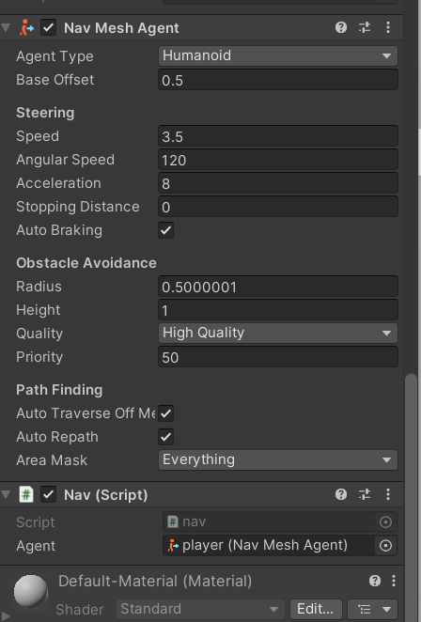

AI NAV EMPTY GAME OBJECT:

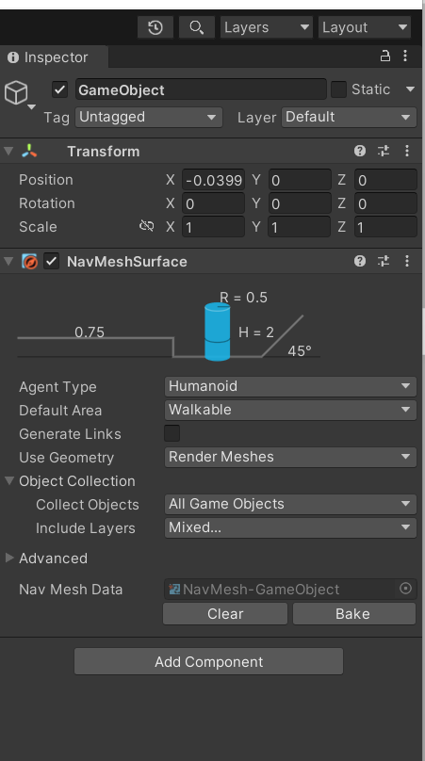

GROUND:

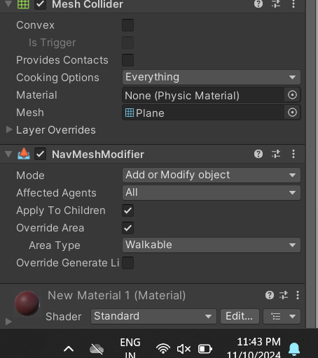

WALLS:

